[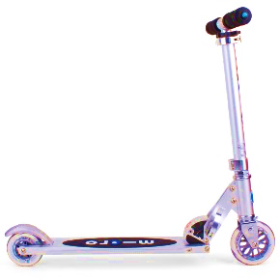](http://www.google.co.uk/url?sa=i&rct=j&q=&esrc=s&source=images&cd=&cad=rja&uact=8&ved=0ahUKEwi_67-91erVAhUDvBQKHbknD98QjRwIBw&url=http%3A%2F%2Flifeandstyle.alexandalexa.com%2Fkids-micro-scooters%2F&psig=AFQjCNF29tpq0_tLoY4m740YHH7T8MNtHw&ust=1503485328890555)**[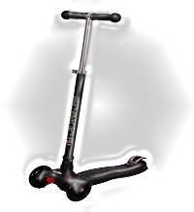](http://www.amazon.in/Ecokic-Maxi-Kids-Scooter-Black/dp/B00UKXUHQO)**[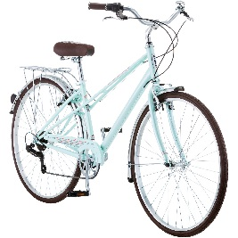](https://www.google.co.uk/url?sa=i&rct=j&q=&esrc=s&source=images&cd=&cad=rja&uact=8&ved=0ahUKEwj81K2YjMPXAhUDPRoKHQNqBSQQjRwIBw&url=https://www.ebay.com/itm/700c-Schwinn-Admiral-Womens-Hybrid-Bike-Mint-Green-/182529483661&psig=AOvVaw2Lm3zNbLVJ7p3ZWKU3hxFA&ust=1510921721529090)**C:\Users\gemma.murphy\AppData\Local\Microsoft\Windows\Temporary Internet Files\Content.IE5\19HEKYD4\MC900347759[1].wmfBike It Crew:**

**School:**

**Bike and Scooter Counts**

|  |  |  |  |
| --- | --- | --- | --- |
| **Date** |  | **Date** |  |
| **Bike numbers** |  | **Bike numbers** |  |
| **Scooter numbers** |  | **Scooter numbers** |  |
| **Date** |  | **Date** |  |
| **Bike numbers** |  | **Bike numbers** |  |
| **Scooter numbers** |  | **Scooter numbers** |  |
| **Date** |  | **Date** |  |
| **Bike numbers** |  | **Bike numbers** |  |
| **Scooter numbers** |  | **Scooter numbers** |  |
| **Date** |  | **Date** |  |
| **Bike numbers** |  | **Bike numbers** |  |
| **Scooter numbers** |  | **Scooter numbers** |  |
| **Date** |  | **Date** |  |
| **Bike numbers** |  | **Bike numbers** |  |
| **Scooter numbers** |  | **Scooter numbers** |  |

**Golden lock is a perfect time for recording your bike and scooter counts. Results collected can also be entered into our database, to do this please register your school at** [www.bikeitdata.org.uk/schools,region](http://www.bikeitdata.org.uk/schools,region) **East of England, Peterborough and select your school.**

**[](http://www.buttonupproductions.com/wp-content/uploads/2012/07/Sustrans-logo-2005_trans_bkgd.png)Happy counting!**

Bike It officers: [Gemma.hughes@sustrans.org.uk](mailto:Gemma.hughes@sustrans.org.uk) and [Eric.schneider@sustrans.org.uk](mailto:Eric.schneider@sustrans.org.uk)

[](http://www.google.co.uk/url?sa=i&rct=j&q=&esrc=s&source=images&cd=&cad=rja&uact=8&ved=0ahUKEwi_67-91erVAhUDvBQKHbknD98QjRwIBw&url=http%3A%2F%2Flifeandstyle.alexandalexa.com%2Fkids-micro-scooters%2F&psig=AFQjCNF29tpq0_tLoY4m740YHH7T8MNtHw&ust=1503485328890555)**[](http://www.amazon.in/Ecokic-Maxi-Kids-Scooter-Black/dp/B00UKXUHQO)**[](https://www.google.co.uk/url?sa=i&rct=j&q=&esrc=s&source=images&cd=&cad=rja&uact=8&ved=0ahUKEwj81K2YjMPXAhUDPRoKHQNqBSQQjRwIBw&url=https://www.ebay.com/itm/700c-Schwinn-Admiral-Womens-Hybrid-Bike-Mint-Green-/182529483661&psig=AOvVaw2Lm3zNbLVJ7p3ZWKU3hxFA&ust=1510921721529090)**C:\Users\gemma.murphy\AppData\Local\Microsoft\Windows\Temporary Internet Files\Content.IE5\19HEKYD4\MC900347759[1].wmfBike It Crew:**

**School:**

**Bike and Scooter Counts**

|  |  |  |  |
| --- | --- | --- | --- |
| **Date** |  | **Date** |  |
| **Bike numbers** |  | **Bike numbers** |  |
| **Scooter numbers** |  | **Scooter numbers** |  |
| **Date** |  | **Date** |  |
| **Bike numbers** |  | **Bike numbers** |  |
| **Scooter numbers** |  | **Scooter numbers** |  |
| **Date** |  | **Date** |  |
| **Bike numbers** |  | **Bike numbers** |  |
| **Scooter numbers** |  | **Scooter numbers** |  |
| **Date** |  | **Date** |  |
| **Bike numbers** |  | **Bike numbers** |  |
| **Scooter numbers** |  | **Scooter numbers** |  |
| **Date** |  | **Date** |  |
| **Bike numbers** |  | **Bike numbers** |  |
| **Scooter numbers** |  | **Scooter numbers** |  |

**Golden lock is a perfect time for recording your bike and scooter counts. Results collected can also be entered into our database, to do this please register your school at** [www.bikeitdata.org.uk/schools,region](http://www.bikeitdata.org.uk/schools,region) **East of England, Peterborough and select your school.**

**[](http://www.buttonupproductions.com/wp-content/uploads/2012/07/Sustrans-logo-2005_trans_bkgd.png)Happy counting!**

Bike It officers: [Gemma.hughes@sustrans.org.uk](mailto:Gemma.hughes@sustrans.org.uk) and [Eric.schneider@sustrans.org.uk](mailto:Eric.schneider@sustrans.org.uk)