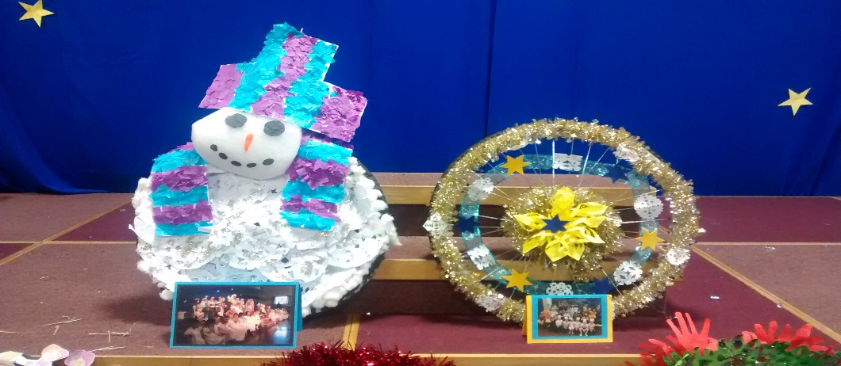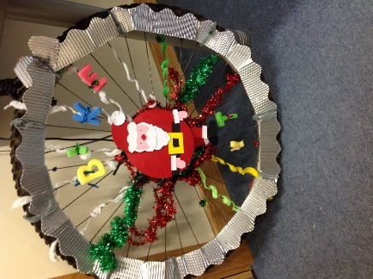**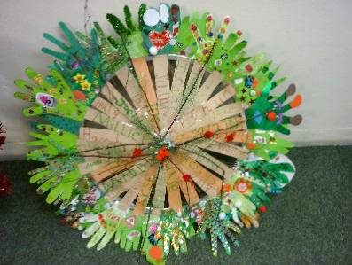Christmas Wreath**

**Poster Competition!**

**Monday 2nd December-Friday 13th December**

[](http://www.google.co.uk/url?sa=i&rct=j&q=&esrc=s&source=images&cd=&cad=rja&uact=8&ved=0ahUKEwj4iNzZuP3OAhVHbRQKHYZODzYQjRwIBw&url=http://1wallpaper.net/christmas-toys-balls-tinsel-hang-rainbow-wallpaper.html&bvm=bv.131783435,d.ZGg&psig=AFQjCNGMFdRO9v__kUxuaApstkMIogWxDQ&ust=1473344117899791)

[](http://www.google.co.uk/url?sa=i&rct=j&q=&esrc=s&source=images&cd=&cad=rja&uact=8&ved=0ahUKEwj4iNzZuP3OAhVHbRQKHYZODzYQjRwIBw&url=http://1wallpaper.net/christmas-toys-balls-tinsel-hang-rainbow-wallpaper.html&bvm=bv.131783435,d.ZGg&psig=AFQjCNGMFdRO9v__kUxuaApstkMIogWxDQ&ust=1473344117899791)

[](http://www.google.co.uk/url?sa=i&rct=j&q=&esrc=s&source=images&cd=&cad=rja&uact=8&ved=0ahUKEwj4iNzZuP3OAhVHbRQKHYZODzYQjRwIBw&url=http://1wallpaper.net/christmas-toys-balls-tinsel-hang-rainbow-wallpaper.html&bvm=bv.131783435,d.ZGg&psig=AFQjCNGMFdRO9v__kUxuaApstkMIogWxDQ&ust=1473344117899791)

[](http://www.sustrans.org.uk/)**Name: Class:**

[](http://www.espmag.co.uk/wp-content/uploads/2013/09/travelchoiceLogo2013-2x292.jpg)**[](http://www.google.co.uk/url?sa=i&rct=j&q=&esrc=s&source=images&cd=&cad=rja&uact=8&ved=0ahUKEwj5tsqSrvjOAhXKvRoKHbbwDFYQjRwIBw&url=http://atos.dvrlists.com/snowflake/&bvm=bv.131783435,d.ZGg&psig=AFQjCNFoI4_dk-vLSiAlL3P5FHTysKAXzQ&ust=1473170247084645)**

**Poster entries must be in by Friday 7th December to allow Bike It Crew time to choose and make the final entry**